Press Release: Children's Book / Roof Greening

Four Friends find a new Home

Children's Book about Roof Greening

"Four Friends find a New Home" - is the title of a recently published Children's book by Optigreen.

Lilly the butterfly, Marie the ladybird, Tom the snail and Nils the grasshopper have a happy life in a flowering meadow. But one day, their living space is destroyed and they have to search for a new home...

The book is about a group of animals that are driven out of their habitat due to construction work and have to start looking for somewhere else to live. After wandering around they end up in a seemingly inhospitable city where they find unexpected shelter and a new home.

This delightful picture book is not only meant for children but young at heart adults.

For your free copy or for more information on Optigreen’s green roof products and services please email info@optigreen.co.uk and visit www.optigreen.co.uk

Publisher: Optigrün international AG, Krauchenwies
Autor: Dr. Gunter Mann
Size: 21 x 21 cm
36 Pages
Price: £2.95

Image:

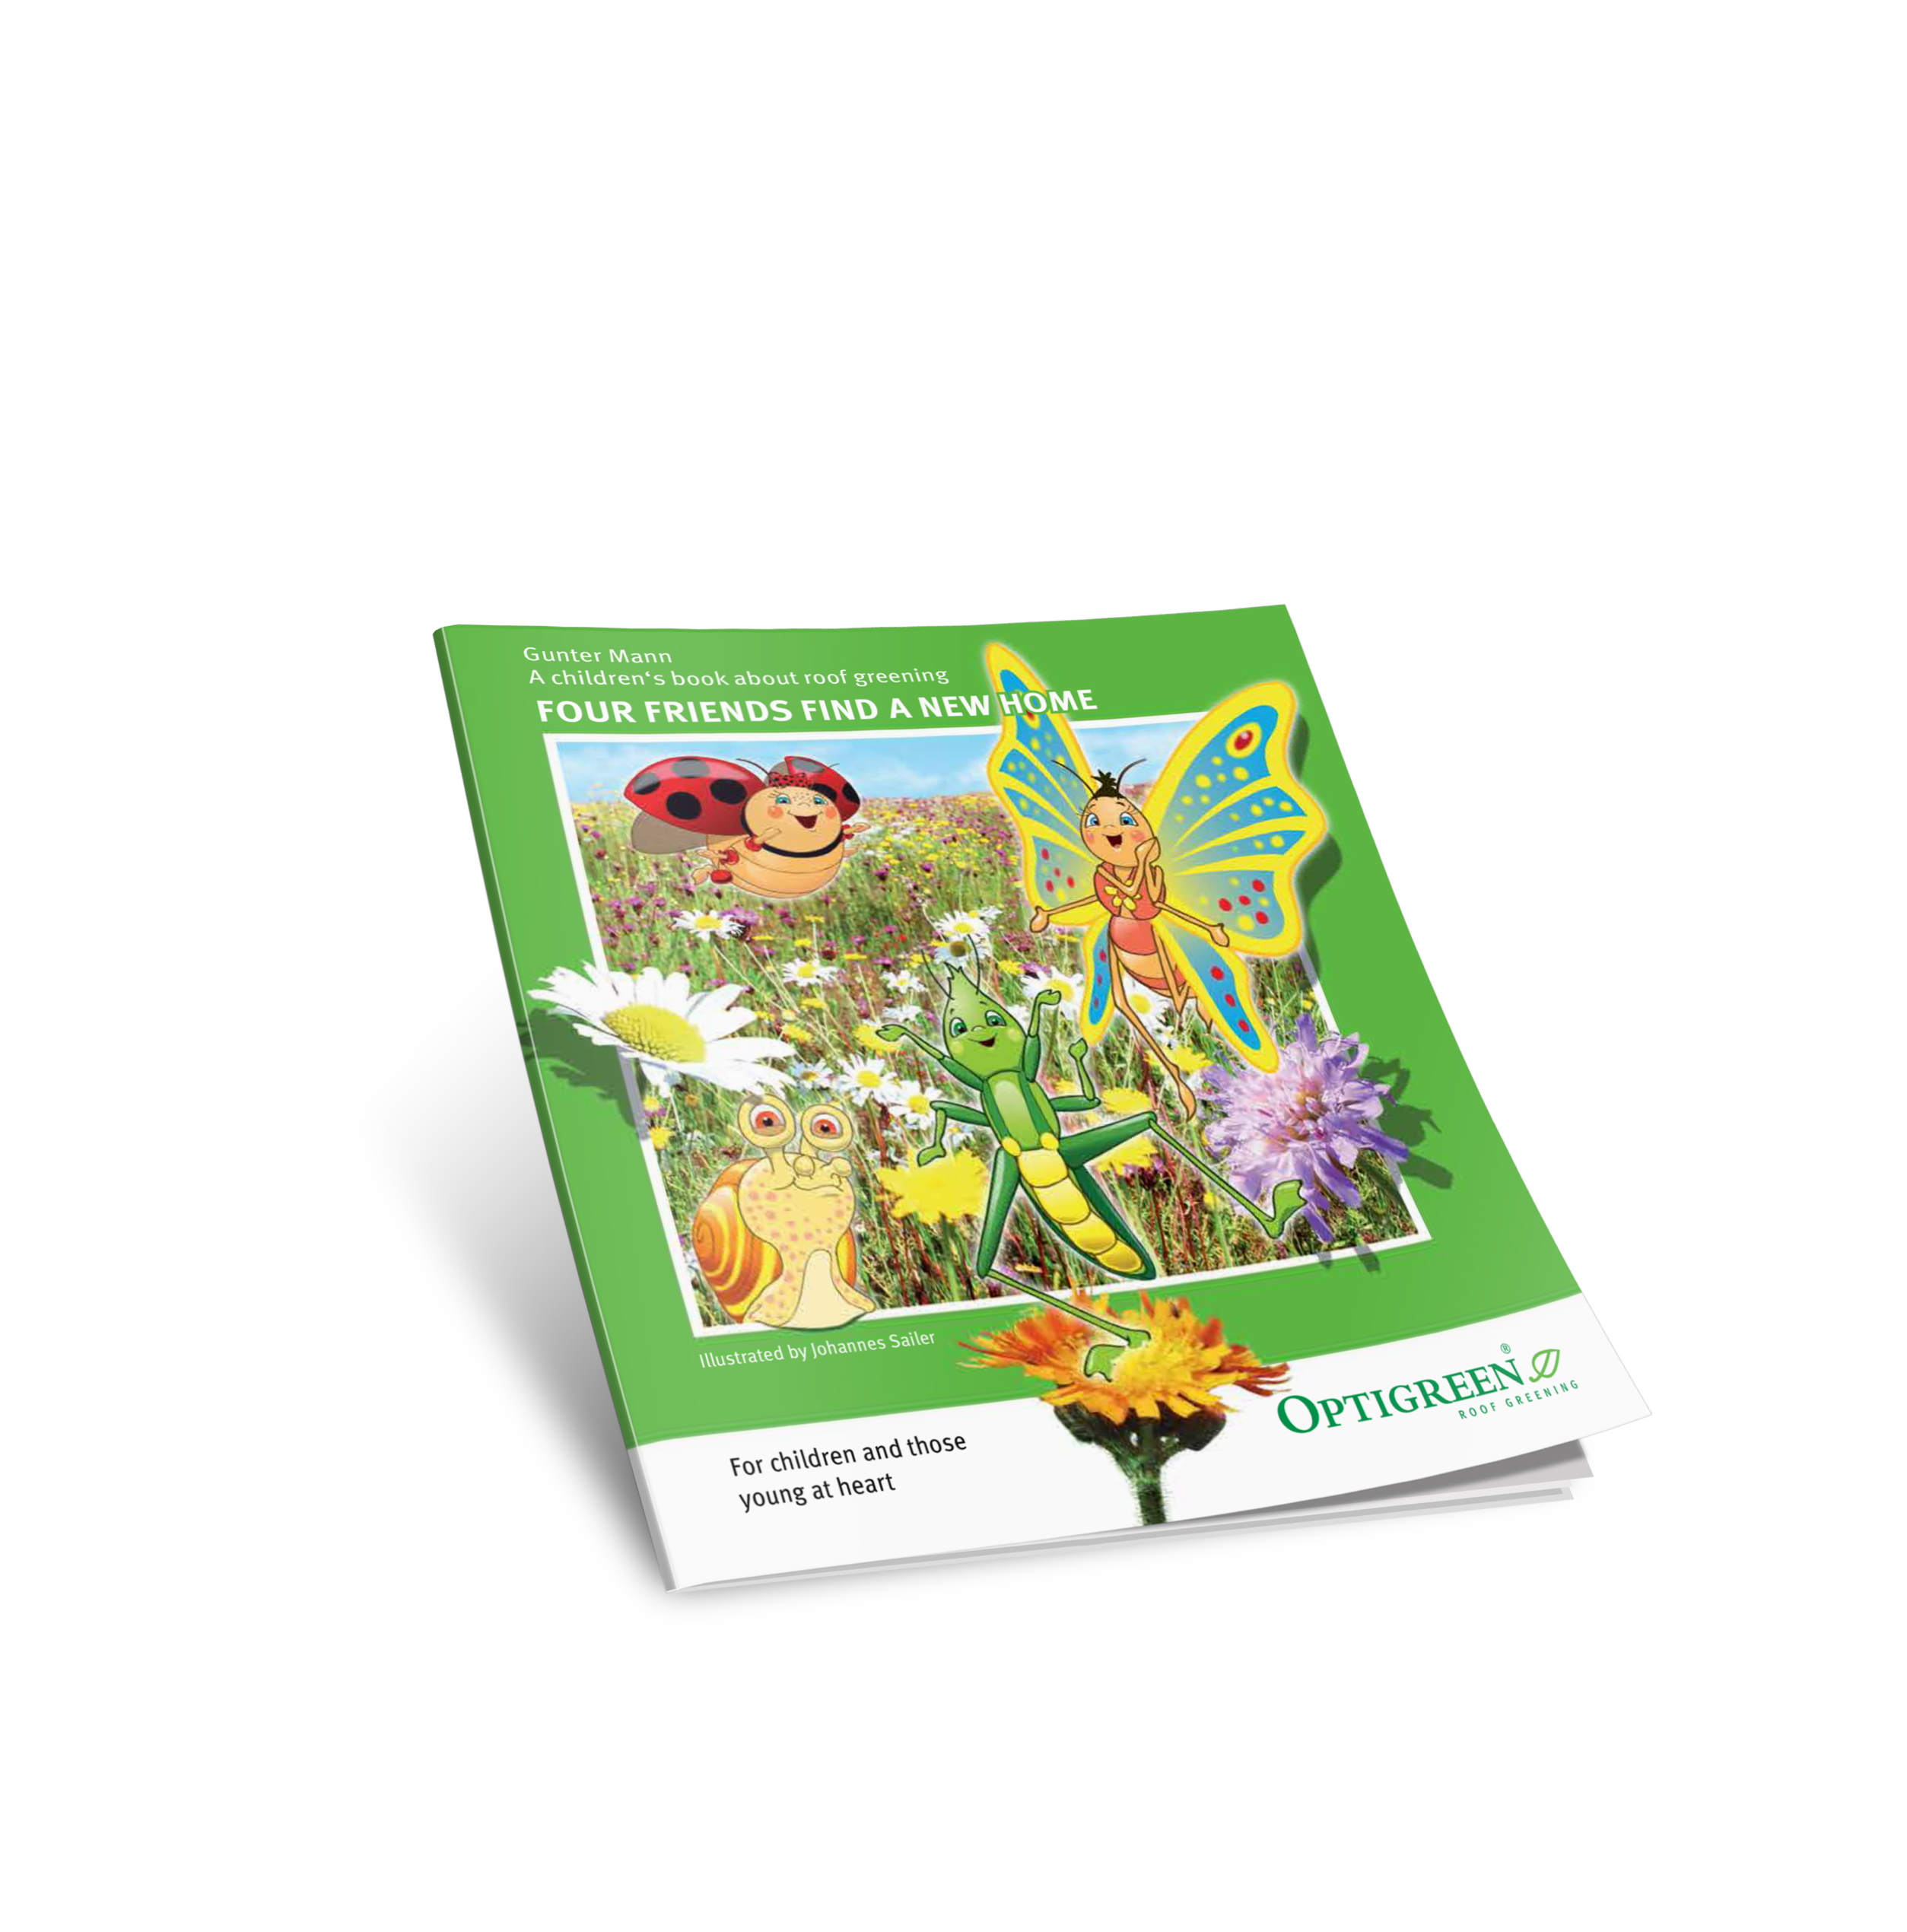

Recently published - the children's book about roof greening. A book for every age!

Optigreen Ltd
Ocean House, Bentley Way
New Barnet
EN5 5FP
Phone: 0203 5899 400
info@optigreen.co.uk
www.optigreen.co.uk

